

**SERVICES**

**The Praetors**

CONTENTS

1 MOBILE APP DEVELOPMENT 2

2 HYBRID MOBILE APP DEVELOPMENT 12

3 NATIVE DEVELOPMENT 21

# MOBILE APP DEVELOPMENT

**META TITLE**: Mobile App Development Services USA| The Praetors

**META DESCRIPTION**: Top-rated custom mobile app development services to help businesses enhance customer experience through disruptive solutions including features like ML/AI, AR/VR and omnichannel connectivity.

**URL**:

**[BANNER 1]**

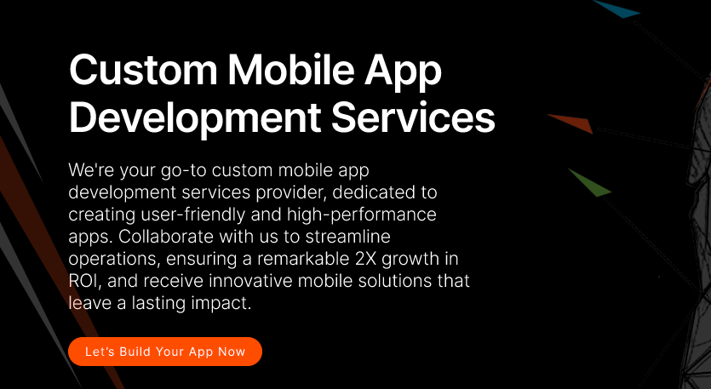

**Custom Mobile App Development Services**

With nearly two decades of delivering cutting-edge solutions, The Praetors is the premier partner for enterprises seeking to elevate their mobile presence. Our dedicated team of developers, designers and product strategists have extensive expertise crafting native applications optimized for iOS and Android environments.

**[LET’S BUILD YOUR SOFTWARE NOW]**

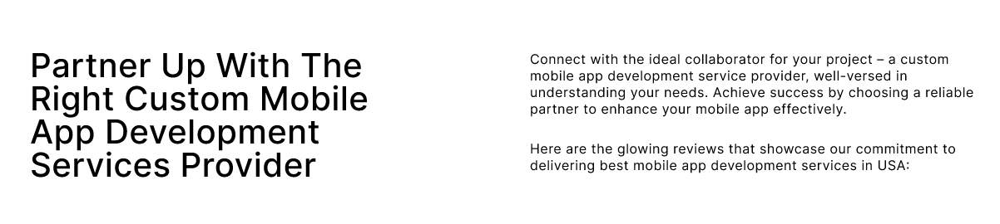

**Seize New Opportunities - Partner with The Praetors for Intuitive Mobile App Design and Development Services**

In today's experience-led business landscape, a compelling mobile presence is crucial for any organization seeking to stay ahead of the curve. As the architects behind countless innovative apps, The Praetors understands how carefully calibrated solutions can deepen user engagement, fuel growth strategies and optimize processes across industries. Our solutions-driven approach in mobile application development leverages deep technological know-how alongside UX design precision to bring ideas to fruition within budget.

With proven delivery of projects both large and small, The Praetors is an elite mobile partner empowering disruptive innovation through intuitively crafted interfaces, advanced integrations and rich feature sets tailored to client ambitions.Top of Form

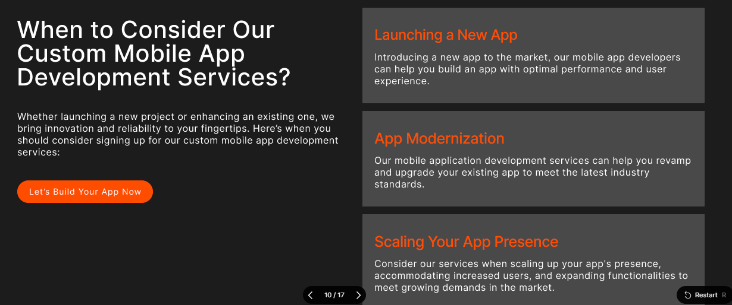

**Level Up Your Mobile Strategy with Our Custom Mobile App Development Services**

Does your app portfolio still meet evolving user demands? The Praetors helps visionary brands transform the way they engage audiences through custom mobile solutions. From concept to maintenance, our dedicated teams handle every facet of the development lifecycle, eliminating roadblocks and accelerating ROI.

|  |  |
| --- | --- |
| **Multi-Platform Accessibility** | Our apps are meticulously crafted to function seamlessly across various platforms, ensuring a consistent user experience regardless of the device or operating system used. |
| **Native App Experience** | Our apps provide users with a native-like experience, boasting smooth performance and intuitive interfaces akin to traditional native applications. |
| **Technical Maintenance & Support** | We offer comprehensive technical maintenance and support services to ensure that your app remains updated, secure, and fully operational, providing peace of mind to both you and your users. |

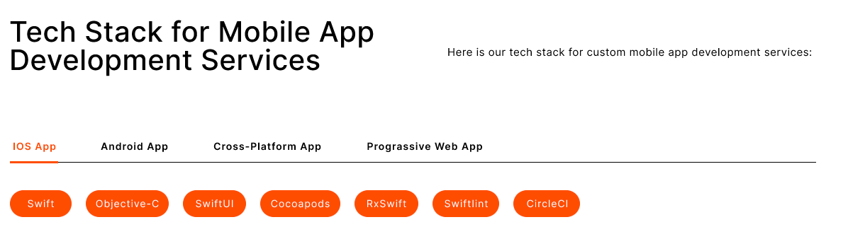

**Revolutionary Mobile App Design and Development Services - Driven by Dynamic Tech Stacks**

We offer custom mobile app development services powered by state-of-the-art technology.

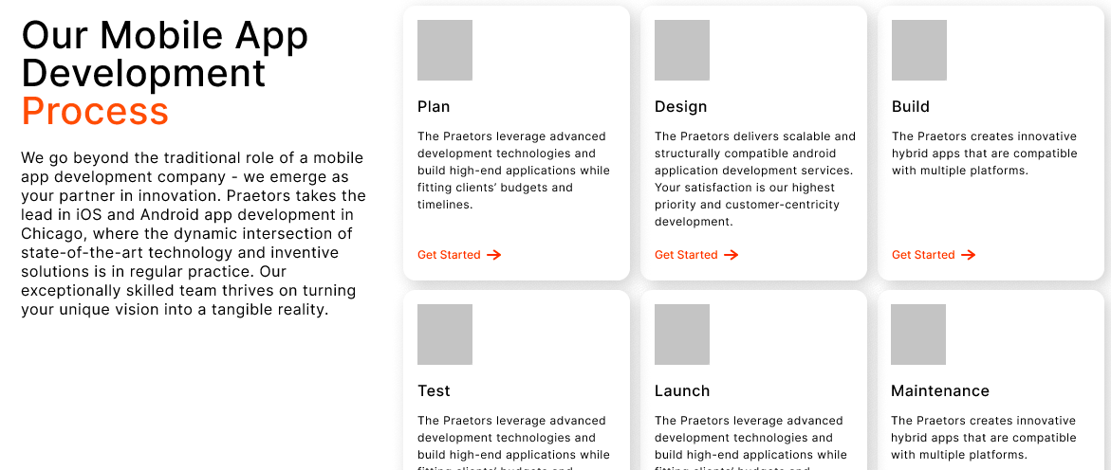

**Discover Our Methodical Mobile App Development Process**

Our expert mobile app developers streamline a process that is carefully structured, with a primary focus on personalized user experiences and the creation of exceptionally efficient solutions. Through our comprehensive range of services, we establish a transparent and dependable partnership, ensuring the delivery of impactful and groundbreaking digital solutions. With our experienced guidance and never-ending dedication, you can trust us to navigate every aspect of the journey professionally and precisely, driving forward transformative results for your business.

|  |  |
| --- | --- |
| **Discovery** | We begin by understanding your needs and goals and gathering essential information to lay the foundation for our collaboration. |
| **Planning** | With a clear understanding, we develop a detailed plan outlining the scope, timeline, and resources required for the project. |
| **Design** | Our team creates intuitive, user-friendly designs, ensuring the mobile apps align seamlessly with your vision and objectives. |
| **Development** | Our skilled mobile app developers bring the designs to life, meticulously coding and building the apps according to the outlined specifications. |
| **Testing** | Rigorous testing procedures are conducted to identify and resolve any issues, ensuring the apps meet high quality and functionality standards. |
| **Launch** | Once thoroughly tested and approved, we deploy the apps, providing comprehensive support and guidance to ensure a smooth transition and optimal performance. |

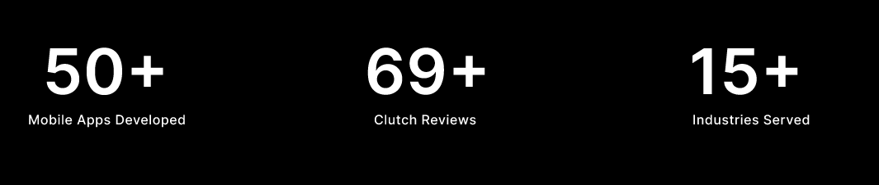

|  |  |  |
| --- | --- | --- |
| **2+**  **Decades of Experience** | **137K+**  **Clients Globally** | **350K+**  **Digital Products Delivered** |

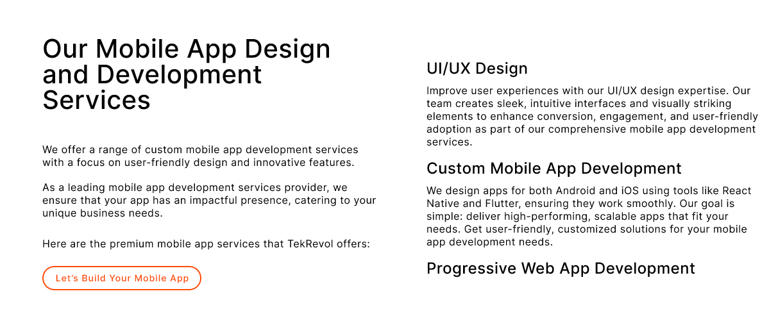

**Drive Innovation, Growth and Success with Top-Notch Mobile Application Development Services**

Our mobile app development experts deliver best-in-class solutions to meet business goals. With expertise in both iOS and Android development, we help businesses leverage emerging technologies to engage customers, boost efficiency and gain a strategic edge.

Every project gets a dedicated team that understands your needs and workflow. From concept to launch and beyond, we ensure apps are seamlessly integrated with your overall digital presence for maximum impact.

Contact us to discuss how to accelerate growth through custom mobile app development services.

|  |  |
| --- | --- |
| **Custom Mobile App Development**  We will work closely with you every step of the way, from concept development to design to building and testing, to create a fully customized native mobile app solution tailored precisely to your unique business needs, goals, workflows and target users. Our dedicated team of developers will ensure the app integrates seamlessly with the rest of your tech systems and digital presence. | **Mobile Web App Development**  For clients who want the reach and accessibility of a responsive mobile experience without device-specific native apps, we design and code high performing, secure progressive web apps that can be easily updated and accessed across iOS and Android devices, as well as tablets and other mobile platforms. Our mobile web apps load fast and have native app capabilities. |
| **Mobile App Maintenance and Support**  Even after an initial successful app launch, ongoing maintenance and improvements are required to keep up with evolving technologies, fix bugs, add features and ensure optimal performance. We offer comprehensive support programs so you can focus on your business while we handle regular updates and troubleshooting to keep your apps fully optimized throughout their lifecycle. | **App Store & Marketplace Optimization**  To boost your ranking, downloads and visibility amongst competitors, we implement strategic localization, search-optimizations, A/B testing and campaign promotions. Ongoing app listing assessments and store analytics aid continual improvements for increased visibility and conversions. |

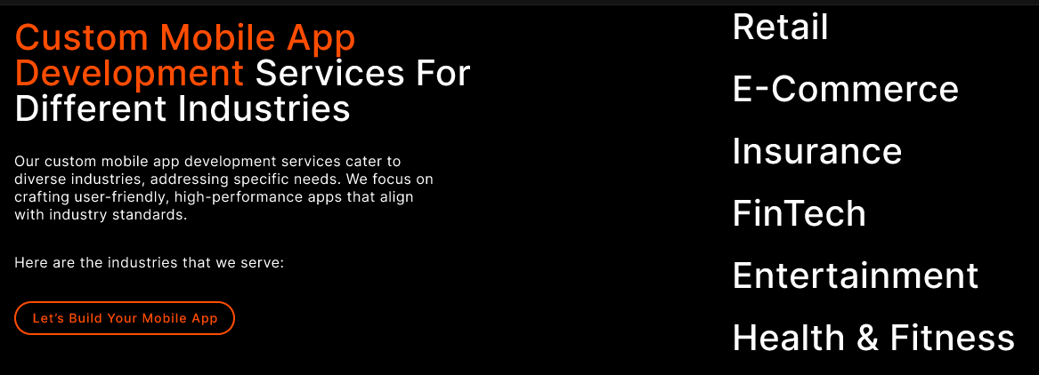

**From Healthcare to Finance: Our Reliable Mobile App Development Expertise Knows No Bounds!**

No matter the field - healthcare, finance, retail or other sectors - our expert mobile app developers understand the nuances of your world. We’ve delivered top-performing apps that drive results for companies in every industry imaginable.

With rigorous compliance and security standards in fields like yours, experience matters. Our team has your back - from the initial concept through long-term support, we ensure your app jumps through every technical and regulatory hoop.

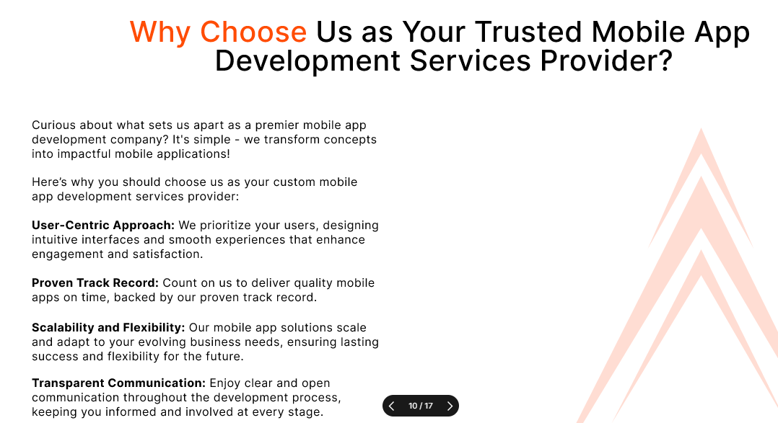

**Our Mission - Empowering Your Journey with Innovation & Integrity**

At our core, our mission is to empower businesses with transformative digital solutions that drive growth and innovation. As a top mobile app development services provider in USA, we are dedicated to leveraging our expertise and creativity to craft bespoke software that meets each client's unique needs and challenges.

Our commitment to excellence guides every aspect of our work, from initial concept to final delivery. We prioritize transparency, communication, and collaboration to ensure that our clients are always informed and involved throughout the app development process. By fostering strong partnerships built on trust and reliability, we aim to become the go-to digital partner for businesses seeking to thrive in today’s competitive landscape.

Our mission is not just to meet expectations, but to exceed them, delivering tangible results and measurable impact for our clients. With a focus on continuous improvement and adaptation to emerging technologies, we strive to stay at the forefront of the industry, driving innovation and pushing boundaries to help our clients succeed in their digital endeavors.

Top of Form

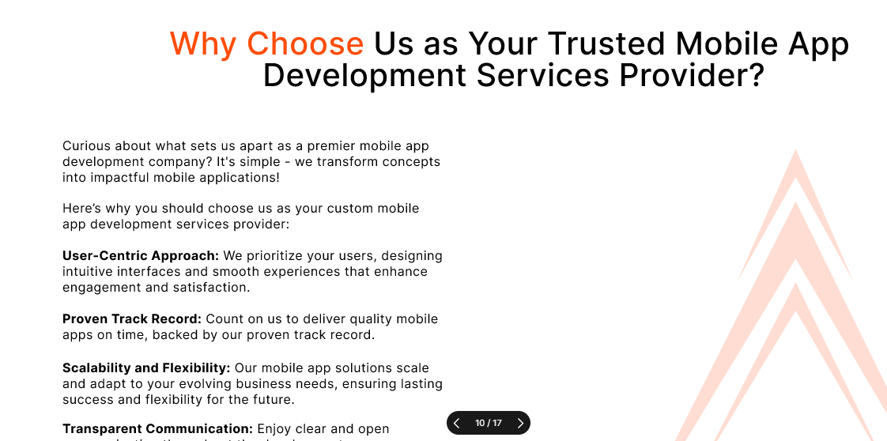

**What Makes The Praetors Your Ideal Mobile Application Development Company?**

With over two decades of experience in the indutry, The Praetors have established a reputation as a premier custom mobile application development services provider through our deep technical expertise and track record of successful projects.

Our talented team approaches each client solution with care, thoroughness and an unmatched understanding of app frameworks, standards and runtime capabilities. By prioritizing architectural quality, performance optimization and accessibility, we develop robust, feature-rich apps that exceed user expectations.

Clients also benefit from our integrated development methodologies, diligent project management and responsive long-term support.

Whether you need to migrate an existing solution or build a new customer-facing platform, our consultative process ensures projects are seamlessly scoped and delivered to achieve your strategic business goals.

|  |  |
| --- | --- |
| **Quality Products** | We’re all about delivering top-notch stuff, making sure it's spot-on and totally reliable, so you're always happy with what you get. |
| **Robust Development** | When we build a custom mobile app, we make sure it's super tough and can handle whatever you need it to do. That's how we roll! |
| **Latest Tech Stack** | We’re all about using the coolest, newest tech to make awesome custom apps that's ahead of the game and helps your business grow. |
| **Complete Transparency** | We’re open books here, keeping you in the loop every step of the way so you know exactly what's happening with your app development project. No secrets here! |

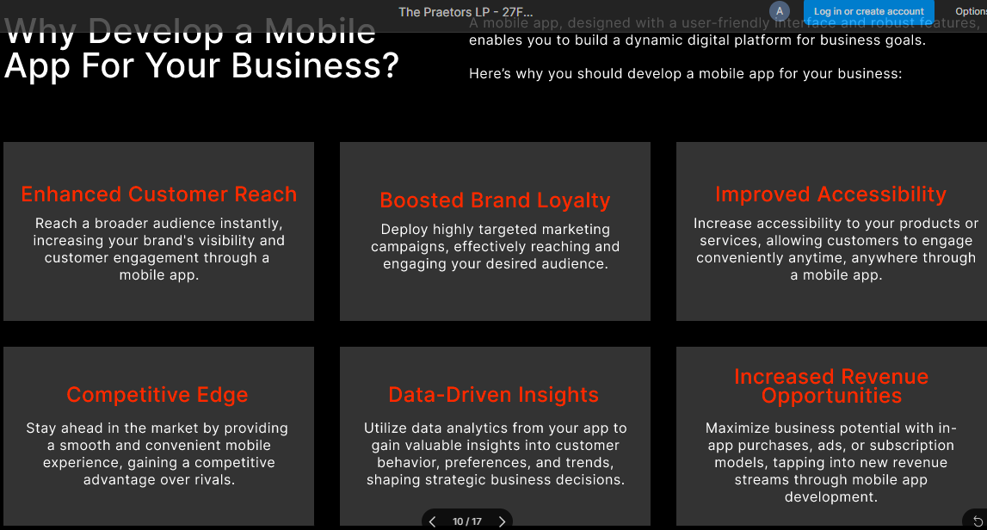

**Why Opt For Custom Mobile App Development Services For Your Business?**

With mobile usage constantly rising, a custom app is essential to engage customers anywhere, anytime on their preferred devices. An app tailored specifically for your business needs and brand allows far deeper engagement and functionality compared to basic website access. You can create seamless experiences, automate processes, and gain valuable usage insights. An app also strengthens your competitive positioning by delivering a consistently superior digital service. Opting for expert development services ensures quality and compliance from project scoping through ongoing support. The result? Increased customer loyalty, conversion rates and data-driven strategic advantages.

|  |  |  |
| --- | --- | --- |
| **Customized Native App Development**  By deeply understanding your business goals and target users, we develop high-performing, fully-customized native apps for iOS and Android that are seamlessly integrated into your overall brand experience and digital strategy. | **Progressive Web App Creation**  We design and code next-level PWAs that are lightning fast, safe and reliable, with app-like capabilities that improve user experience and drive continual engagement through regular updates and new features. | **Cross-Platform Development**  Leveraging shared codebases, we simplify scaling to multiple platforms and deliver pixel-perfect, high-converting experiences consistently across devices with reduced costs and time to market. |
| **Native App Integration**  We ensure seamless integration of your custom mobile experience with existing digital properties, backend systems and third party services through secure APIs and other interfaces. | **App Lifecycle Management**  Ongoing maintenance by our team keeps apps optimized over time, with quick and reliable bug fixes, performance enhancements, new features and compliance with emerging standards. | **UI/UX Design Consulting**  Our experts analyze user behavior and industry standards to craft intuitively engaging, on-brand interface designs that optimize usability, conversions and long-term engagement on mobile. |

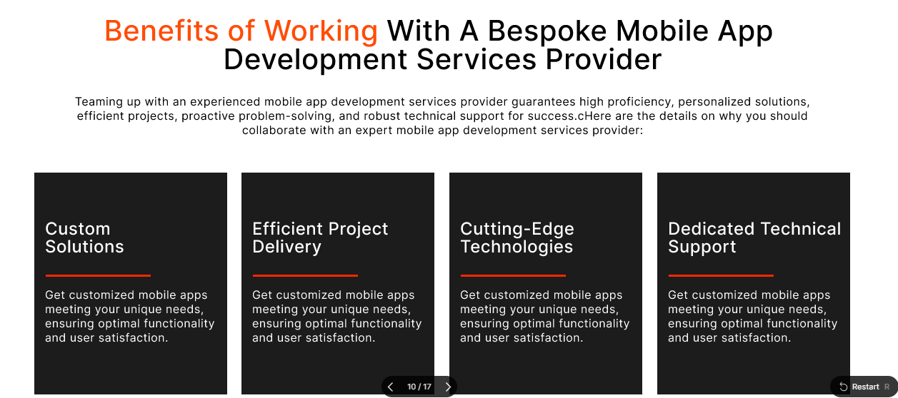

**Benefits of Working With A Professional & Reliable Custom Mobile App Development Services Provider**

Partnering with The Praetors offers numerous benefits. From expert guidance and streamlined communication to high-quality solutions and timely delivery, you can trust in our expertise to enhance your business operations and drive growth in today’s competitive market landscape.

|  |  |  |  |
| --- | --- | --- | --- |
| **Future-Ready Products**  We're all about staying ahead of the game, crafting innovative solutions that'll tackle tomorrow's challenges head-on. | **Dedicated Team**  Count on us to bring your ideas to life! Our mobile app developers are dedicated, skilled, and ready to make your vision a reality. | **Customer Experience**  We’re here to make your experience seamless and personalized, tailored just for you and your success. | **Satisfaction Guarantee**  Your satisfaction is our top priority. We're committed to making sure you're thrilled with the results. |

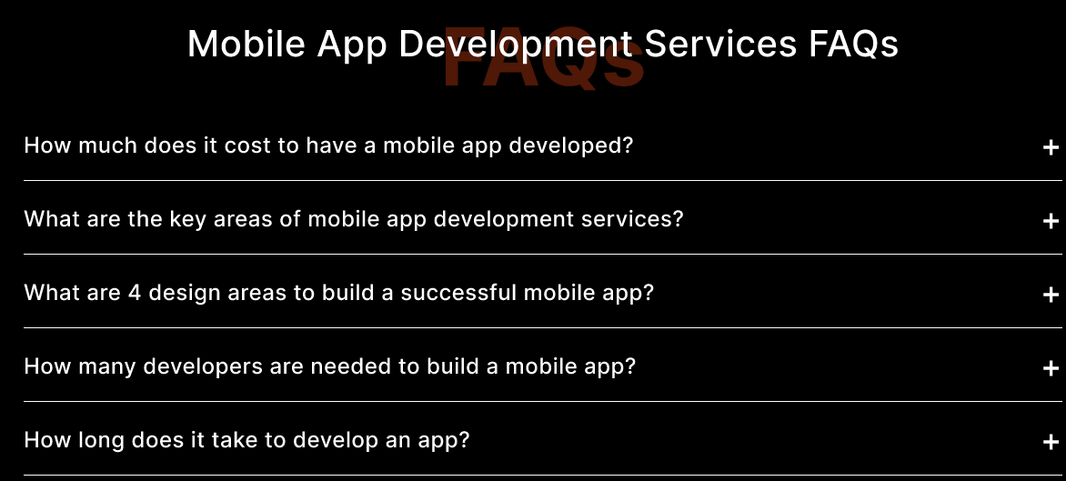

**Custom Mobile App Development Services FAQs**

**How long does it take to develop a mobile app?**

Timeframes can vary significantly depending on features, but on average plan for 3-6 months for native Android/iOS apps. Simpler web apps may only take 1-3 months.

**What is the average cost of developing a mobile app?**

Costs depend hugely on features and platform(s). Basic apps start around $25k, while fully-featured hybrid/native apps can range $50k-$250k and up for more complex enterprise solutions.

**Can you develop an app for both Android and iOS?**

Yes, we offer cross-platform development that allows an app to run on multiple systems like iOS and Android simultaneously, minimizing costs and maximizing client reach.

**What is the app maintenance process after launch?**

We offer ongoing maintenance packages that include updates, backups, version control, bug fixes and support to ensure your app always functions properly and meets evolving business needs.

**How do mobile apps help grow a business?**

Custom apps improve customer engagement, help automate processes, capture valuable usage data, increase brand awareness and trigger higher lifetime value through a better mobile experience and accessibility.

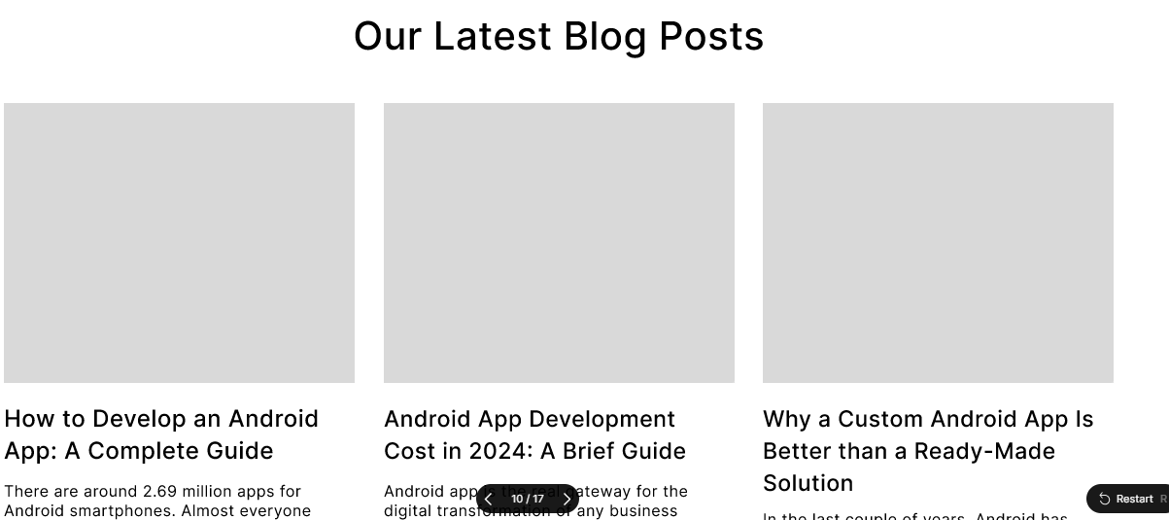

**READ OUR LATEST BLOG**

**[BLOGS HERE]**

# HYBRID MOBILE APP DEVELOPMENT

**META TITLE**: Top-rated Hybrid Mobile App Development Company | The Praetors

**META DESCRIPTION**: As a leading hybrid mobile app development company in the US, we create high-quality, fully-responsive cross-platform apps for iOS, Android and web using shared code.

**URL**:



**Best Hybrid App Development Company**

Trusted by hundreds of startups and enterprises globally, The Praetors is recognized as the industry-leading hybrid mobile app development company in USA. With a portfolio of award-winning apps delivered on time and on budget, our team of highly skilled developers leverages the latest cross-platform technologies to build powerful, feature-rich hybrid solutions scaling seamlessly across devices. Partner with the experts for innovative apps that accelerate your business.



**Partner with Expert Hybrid App Developers for Robust, Performance-Driven Products!**

Whether your goal is to reshape industry processes, boost customer engagement or scale operations globally, crafting high-performance hybrid apps is key to success. However, without the right expertise, your project faces unnecessary risks. As a trusted leader, our team of specialized developers create robust, secure solutions optimized for any business goal or platform. Through stringent quality control and testing methodologies, we guarantee fluid UX and fast response times under heavy usage. Plus, our agile process empowers continuous improvement even post-launch.

Partner with the experts and watch robust hybrid products supercharge your business!



**When to Consider Hybrid App Development Services?**

If you require a high-quality mobile experience but want to reduce costs, get to market faster or need to support multiple platforms, hybrid app development offers clear benefits over native. By building apps using shared code, hybrid allows scaling to Android, iOS and mobile web from a single codebase. It's perfect for projects on a budget or time crunch, or businesses targeting broad customer reach across device types. Hybrid apps also enable powerful features like cross-platform integration and offline functionality.

|  |  |
| --- | --- |
| **Cross-Platform Compatibility** | Hybrid apps allow seamless scalability to the major mobile platforms of Android, iOS, and mobile web using a single codebase, significantly reducing development workload and costs compared to separate native apps. This unified code makes hybrid an ideal option for businesses seeking wide customer reach. |
| **Fast Development** | By leveraging common frontend technologies such as HTML5, CSS and JavaScript, our hybrid methodology streamlines the creation of robust cross-platform solutions at a much faster pace than native. This accelerated timeline makes hybrid the smarter option for projects requiring compressed delivery. |
| **Native-Like Performance** | Through efficient code partitioning and optimization, we craft hybrid experiences that harness the power of native capabilities while retaining a web-like development model. The resulting hybrid apps load instantly and interact smoothly even under intensive use, indistinguishable in speed and functionality from their native equivalents. |



**Innovative Hybrid App Development, Driven by Dynamic Tech Stacks**

We offer custom hybrid app development solutions powered by state-of-the-art technology.



**Our Seamless Hybrid App Development Services Process**

Our seamless development process starts with thorough discovery and analysis to understand your unique needs and goals. Our expert hybrid app developers then craft optimized solutions through interactive prototyping and testing. Solid coding practices ensure robust, scalable products delivered through an iterative approach. On-time, on-budget delivery is complemented by ongoing support, enabling your app to continually meet evolving business demands.

|  |  |
| --- | --- |
| **Discovery** | We begin by understanding your needs and goals and gathering essential information to lay the foundation for our collaboration. |
| **Planning** | With a clear understanding, we develop a detailed plan outlining the scope, timeline, and resources required for the project. |
| **Design** | Our team creates intuitive, user-friendly designs, ensuring the app aligns seamlessly with your vision and objectives. |
| **Development** | Our skilled team of custom developers brings the designs to life, meticulously coding and building the app according to the outlined specifications. |
| **Testing** | Rigorous testing procedures are conducted to identify and resolve any issues, ensuring the app meets high standards of quality and functionality. |
| **Launch** | Once thoroughly tested and approved, we deploy the application, providing comprehensive support and guidance to ensure a smooth transition and optimal performance. |



|  |  |  |
| --- | --- | --- |
| **2+**  **Decades of Experience** | **137K+**  **Clients Globally** | **350K+**  **Digital Products Delivered** |



**Benefits of Partnering with Top-Rated Hybrid Mobile App Development Company in USA**

Partnering with The Praetors offers unparalleled advantages. As the industry leader, our team delivers unmatched quality, reliability and end-to-end service. You gain expert guidance from concept to launch and beyond from developers certified in the latest technologies. Plus, our rigorous processes ensure innovative hybrid solutions that elevate your brand and seamlessly fuse into any business ecosystem. Partner with The Praetors, the proven innovators, and watch your project exceed all targets with an investment you can trust.

|  |  |
| --- | --- |
| **Expert Hybrid Development**  As the leader in hybrid technologies, The Praetors’ expert hybrid app developers craft feature-rich, fast solutions that cut through complexity. You benefit from unparalleled specialized expertise, delivering polished cross-platform apps meeting even the most ambitious requirements. | **Flawless Project Delivery**  The Praetors applies rigorous Agile methodologies, sprinting iteratively to achieve milestones together. Combined with proven project management systems, you gain full visibility and confidence apps launch triumphantly on schedule and budget for maximum business impact. |
| **Cutting-Edge Solutions**  By investing continuously in innovation, The Praetors understands the latest trends. As your dedicated partner, you access strategically unmatched hybrid models optimized for industry-leading services, branding or next-gen user experiences to outpace competitors. | **Enduring Partnership**  The Praetors prides itself on lifetime collaboration. Beyond development, valuable support endures through maintenance, updates and scalability planning. You establish rewarding long-term ties and a trusted advocate dedicated to technology's role in elevating your larger company vision. |



**Ultimate Hybrid App Development Solutions Specific for Every Industry**

Whether you operate in healthcare, finance, retail, government or another sector, our expert team provides ultimate hybrid app development solutions tailored specifically for your industry's unique needs and regulatory landscape. Leveraging deep experience building solutions for various verticals, we craft secure, fully-compliant digital tools optimized for your workflows and business goals.



**Our Mission - Empowering Your Journey with Innovation & Integrity**

At our core, our mission is to empower businesses with transformative digital solutions that drive growth and innovation. We are dedicated to leveraging our expertise and creativity to craft bespoke digital products that meet the unique needs and challenges of each client.

Our commitment to excellence guides every aspect of our work, from initial concept to final delivery. We prioritize transparency, communication, and collaboration to ensure that our clients are always informed and involved throughout the hybrid app development process. By fostering strong partnerships built on trust and reliability, we aim to become the go-to digital partner for businesses seeking to thrive in today’s competitive landscape.

Our mission is not just to meet expectations, but to exceed them, delivering tangible results and measurable impact for our clients. With a focus on continuous improvement and adaptation to emerging technologies, we strive to stay at the forefront of the industry, driving innovation and pushing boundaries to help our clients succeed in their digital endeavors.



**Unlock the Power of Robust Hybrid App Development with The Praetors**

When you partner with The Praetors, a leading and reliable hybrid mobile app development company in the US, you’re selecting a seasoned team of experts poised to transform your concepts into successful applications.

We commence by attentively listening to your requirements, ensuring a thorough comprehension of your aspirations.

Subsequently, our adept developers utilize their technical prowess to craft applications that not only function seamlessly but also delight end users.

Our commitment extends beyond development; we pledge ongoing support and updates to maintain the excellence of your application, allowing you to concentrate on business growth and customer satisfaction.

|  |  |
| --- | --- |
| **Quality-First Approach** | We’re all about delivering top-notch stuff, making sure it's spot-on and totally reliable, so you're always happy with what you get. |
| **Robust Development** | When we build a custom app, we make sure it’s brilliant in every way and functions fully, handling whatever you need it to do. That’s how we roll! |
| **Latest Tech Stack** | We’re all about using the coolest, newest tech to make an awesome custom app that’s ahead of the game and helps your business grow. |
| **Complete Transparency** | We’re open books here, keeping you in the loop every step of the way so you know exactly what's happening with your custom web app development project. No secrets here! |



**Why Opt For Hybrid App Development Services For Your Business?**

Hybrid apps unlock unrivaled mobile solutions at an attractive price point. As the one-stop shop for all platforms, they future-proof your technology against device changes while preventing vendor lock-in. Scalable hybrids ensure universal access to vital tools that drive workforce productivity and customer satisfaction. All without limiting functionality or slowing release cycles.

Opt now for a cost-effective and fully-customized mobile experience that takes your innovation further, faster.

|  |  |  |
| --- | --- | --- |
| **Increased Operational Efficiency**  A tailored solution streamlines complex workflows to save time and resources through automation and integration. | **Enhanced Customer Experience**  Customizing interactions based on research builds loyalty by satisfying precise needs through an intuitive, consistent experience. | **Actionable Business Insights**  Integrating diverse internal and external data sources unleashes customized analytics to reveal patterns that guide strategic decisions. |
| **Stronger Brand Identity**  Incorporating your unique messaging, look and feel establishes a consistent digital presence that deepens customer relationships. | **Future Growth Capabilities**  Innovative features keep your app aligned with evolving needs while its flexibility supports business transformations. | **Competitive Advantage**  A proprietary solution delivers invaluable functionality that competitors cannot easily replicate, keeping your organization ahead of the curve. |



**Perks of Working with an Expert Hybrid App Development Company**

Partnering with The Praetors ensures a seamless journey towards digital transformation through hybrid app development. We carefully handle every aspect to deliver a superior experience, allowing you to effortlessly focus on your business growth.

|  |  |  |  |
| --- | --- | --- | --- |
| **Future-Ready Products**  We're all about staying ahead of the game, crafting innovative solutions that'll tackle tomorrow’s challenges head-on. | **Dedicated Team**  Count on us to bring your ideas to life! Our expert hybrid app developers are dedicated, skilled, and ready to make your vision a reality. | **Customer Experience**  We’re here to make your experience seamless and personalized, tailored just for you and your success. | **Satisfaction Guarantee**  Your satisfaction is our top priority. We’re committed to making sure you’re thrilled with the results. |



**Hybrid Application Development Services: FAQs**

**What is a hybrid mobile app?**

A hybrid app is built with web technologies like HTML, CSS and JavaScript which are wrapped inside a native container. This allows apps to be deployed across platforms like iOS and Android.

**How long does hybrid app development take?**

Estimates vary based on features and requirements but simple hybrid apps can generally be built within 2-3 months. Complex apps may take 6-9 months or longer.

**What are the advantages of hybrid apps?**

Cross-platform deployment, reduced costs, shorter development times, reuse of web-based skills, native-like performance and features are some key benefits.

**How much does hybrid app development cost?**

Cost depends on features, platforms and development hours required. Basic hybrid apps start from $15k-$50k. Complex enterprise apps range from $100k-$500k or more.

**What skills are required for hybrid app development?**

Proficiency in HTML/CSS, JavaScript frameworks like Angular/React, front-end skills, back-end integration knowledge along with experience building responsive designs for multiple platforms.



**READ OUR LATEST BLOG**

**[BLOGS HERE]**

# NATIVE DEVELOPMENT

**META TITLE:** Native Mobile App Development Company | The Praetors

**META DESCRIPTION**: As a leading native mobile app development company, The Praetors creates high-quality, platform-specific apps meeting the unique requirements of your business or brand within timeline and budget.

**URL**:



**Top-Notch Native Mobile App Development Services**

Looking to optimize your mobile product but unsure where to start? Our expert native mobile app developers handle every project detail, from initial scoping and UX design to thorough testing and maintenance support. You gain a dedicated point of contact ensuring crystal-clear communication and management across all stages.



**Native Mobile Application Development for Robust, Performance-Driven Digital Products!**

Take your mobile products to the next level with best-in-class native development from The Praetors. As the go-to leader for custom iOS and Android solutions, we combine cutting-edge technical skills with strategic guidance. You gain optimized apps engineered for seamless functionality, intuitive designs and stellar performance. Leverage our extensive industry knowledge to future-proof your portfolio with flexible, scalable offerings increasing user engagement.

Entrust The Praetors to strengthen your brand reputation through high-caliber digital solutions.



**When to Consider Our Native Mobile App Development Services?**

Choose The Praetors for your next native mobile application development project if speed, reliability and deep platform integration are priorities. Our native apps leverage the full power of iOS and Android to provide snappy performance, smooth animations and access to device capabilities like Bluetooth, fingerprint scanning and more.

If you want users to easily discover and engage with all your app has to offer through intuitive experiences composed specifically for each platform, our native mobile app development services can transform your vision into high-converting apps that feel like they belong.

|  |  |
| --- | --- |
| **Superior Performance** | Native apps developed by The Praetors utilize the full processing power of mobile devices, resulting in ultra-fast load times, instant responsiveness and battery-saving efficiency. |
| **Seamless Integration** | Our native mobile solutions integrate effortlessly with platform-specific features for richer user experiences. Apps utilize the latest APIs, cameras, locations and other device capabilities. |
| **Continuous Improvement** | The agile development process we follow allows for incremental updates and new features to be added after launch. This means apps always remain engaging as technology and needs evolve. |



**Reliable Native Mobile App Development, Driven by Dynamic Tech Stacks**

We offer top native mobile app development service powered by state-of-the-art technology.



**Our Efficient Native Mobile Application Development Process**

The Praetors follows a finely-tuned process to ensure project delivery is streamlined and smooth. We start with comprehensive discovery sessions to fully understand your goals and vision. Prototypes are then created for user testing and feedback. After design is finalized, our dedicated teams of iOS and Android programmers collaborate using agile methodologies with daily standups to implement the app. Robust testing keeps bugs at bay. Apps are launched, optimized and maintained through ongoing support.

|  |  |
| --- | --- |
| **Discovery** | We begin by understanding your needs and goals and gathering essential information to lay the foundation for our collaboration. |
| **Planning** | With a clear understanding, we develop a detailed plan outlining the scope, timeline, and resources required for the project. |
| **Design** | Our team creates intuitive, user-friendly apps, ensuring the ecommerce project aligns seamlessly with your vision and objectives. |
| **Development** | Our skilled developers bring the app to life, flawlessly coding and building the digital product according to the outlined specifications. |
| **Testing** | Rigorous testing procedures are conducted to identify and resolve any issues, ensuring the app meets high standards of quality and functionality. |
| **Launch** | Once thoroughly tested and approved, we deploy the application, providing comprehensive support and guidance to ensure a smooth transition and optimal performance. |



|  |  |  |
| --- | --- | --- |
| **2+**  **Decades of Experience** | **137K+**  **Clients Globally** | **350K+**  **Digital Products Delivered** |



**Explore Our Game-Changing Native Mobile App Development Services**

Take your mobile experience to the next level with The Praetors' unparalleled native app services. Whether you need an engaging entertainment app or a powerful business solution, our expert teams utilize the latest techniques to transform your ideas into best-in-industry user experiences. Through agile development, deep platform integration and quality assurance experts, we ensure high performance and lasting value. Plus, our iterative process means your app can continuously captivate as technology advances. Let our passion for innovation and obsession with details change your mobile destiny.

|  |  |
| --- | --- |
| **Performance Optimization**  Our developers meticulously analyze code performance to ensure streamlined running speed. Strategies like compressed assets, optimized database queries and judicious threading maximize efficiency so apps feel lightning fast no matter the device or internet connection. | **Feature-Rich Designs**  Every interaction, animation and visual is meticulously crafted to provide seamless functionality and wow users. We incorporate the latest design trends and leverage each platform's unique abilities to deliver intuitive experiences that feel convenient, engaging and aesthetically pleasing. |
| **Robust Quality Control**  A rigorous testing process takes place at all stages - from unit and regression testing by our programmers to beta deployments. We identify and fix bugs efficiently thanks to automated testing frameworks. Extensive QA coverage ensures apps are stable, secure and compliant on launch as well as with future updates through ongoing monitoring. | **Seamless Integration**  Advanced development techniques allow our apps to effortlessly access device capabilities and leverage the latest OS features. Whether it's push notifications, Siri/Google integration, location services or biometric authentication, we incorporate the proper APIs for enriched functionality befitting each unique platform.Top of Form |



**Industries We Serve with Our Top-Notch Native Mobile App Development Services**

The Praetors transforms businesses through groundbreaking app solutions, empowering them to maximize their capabilities. Specializing in cutting-edge iOS and android app native app development, we create tailored solutions for various industries, reshaping traditional approaches and delivering exceptional results.

Here are the sectors we cater to:



**Our Mission - Empowering Your Journey with Innovation & Integrity**

At our core, our mission is to empower businesses with transformative digital solutions that drive growth and innovation. We are dedicated to leveraging our expertise and creativity to craft bespoke digital products that meet the unique needs and challenges of each client.

Our commitment to excellence guides every aspect of our work, from initial concept to final delivery. We prioritize transparency, communication, and collaboration to ensure that our clients are always informed and involved throughout the native app development process. By fostering strong partnerships built on trust and reliability, we aim to become the go-to digital partner for businesses seeking to thrive in today’s competitive landscape.

Our mission is not just to meet expectations, but to exceed them, delivering tangible results and measurable impact for our clients. With a focus on continuous improvement and adaptation to emerging technologies, we strive to stay at the forefront of the industry, driving innovation and pushing boundaries to help our clients succeed in their digital endeavors.



**Choosing The Praetors As Your Reliable Native Mobile Application Development Partner**

Partnering with The Praetors for your native app development needs offers several advantages. Firstly, we possess extensive knowledge of both traditional and emerging technologies, ensuring we employ the most suitable technology stack and agile methodologies for your project.

Secondly, we boast a team of elite native mobile app developers and QA engineers dedicated to ensuring the performance and scalability of your digital assets.

Lastly, we prioritize meeting the evolving needs of your customers, crafting apps with highly functional features that deliver exceptional user experiences.

|  |  |
| --- | --- |
| **Quality-First Approach** | We’re all about delivering top-notch stuff, making sure it's spot-on and totally reliable, so you're always happy with what you get. |
| **Robust Development** | When we build a custom ecommerce app, we ensure it’s brilliant in all ways and functions fully, handling whatever you need. That’s how we roll! |
| **Latest Tech Stack** | We’re all about using the coolest, newest tech to make an awesome custom app that’s ahead of the game and helps your business grow. |
| **Complete Transparency** | We’re open books here, keeping you in the loop every step of the way so you know exactly what's happening with your custom native app development project. No secrets here! |



**Advantages Native Mobile App Development Services Offer for Your Business Digitization**

Our native mobile app development services provide the perfect solution for ambitious businesses looking to digitally transform. By creating a polished, fully-customized app experience that leverages each platform's strengths, we help optimize processes, boost customer engagement and drive stronger brand awareness all with the superior performance, seamless functionality and continuous innovation that only native apps can offer.

|  |  |  |
| --- | --- | --- |
| **Superior User Experience**  We create pixel-perfect designs and smooth animations that utilize each platform's unique features for an engaging experience your audience will love. | **Improved Customer Retention**  Compelling apps keep users coming back while easier access to your services through intuitive apps increases loyalty and lifespan. | **Boosted Reach & Revenue**  Well-designed, high-converting native apps help you access lucrative new markets and provide new purchasing channels to grow your business. |
| **Increased Brand Awareness**  Native apps embedded with your brand and installed on millions of devices become a continuously promoting mobile billboard wherever your customers are. | **First-mover Advantage**  Be the first in your field to harness the power of mobile with a featured-rich app that leaves competitors playing catch up. | **Accelerated Process Efficiency**  Native apps streamline operations with automated workflows for improved productivity and the ability to perform tasks anywhere, anytime on any device. |



**Perks of Partnering with a Leading Native Mobile App Development Company**

When you collaborate with The Praetors, a top-rated top native mobile app development services provider, you unlock a pathway to accelerated business growth. Our innovative services offer a multitude of benefits that can maneuver your business forward, ensuring success in the competitive market landscape.

|  |  |  |  |
| --- | --- | --- | --- |
| **Future-Ready Products**  We’re all about staying ahead of the game, crafting innovative solutions that'll tackle tomorrow’s challenges head-on. | **Dedicated Team**  Count on us to bring your ideas to life! Our native mobile app developers are dedicated, skilled, and ready to make your vision a reality. | **Customer Experience**  We’re here to make your experience seamless and personalized, tailored just for you and your success. | **Satisfaction Guarantee**  Your satisfaction is our top priority. We’re committed to making sure you’re thrilled with the results. |



**Native Mobile Application Development FAQs**

**What is native mobile application development?**

It is the process of developing apps specifically for mobile platforms like iOS and Android using their native languages - Objective C/Swift for iOS and Java/Kotlin for Android. This allows apps to leverage each platform's unique capabilities.

**What are the advantages of native apps?**

Native apps have superior performance, seamless integration of device features, Snappier user experiences and ability to be easily discovered/downloaded due to presence in app stores.

**How long does it take to develop a native app?**

Timelines vary depending on features, but typical ranges are 3-6 months for simpler apps and 6-12 months for complex enterprise-grade apps. Our agile process keeps projects on schedule.

**What is the average cost of developing a native app?**

Prices range from $50,000-500,000 based on complexity, features, platform, location of development team and choice of technologies/frameworks. We provide transparent, competitive quotes.

**What platforms does native development support?**

We focus on developing for the two dominant platforms - iOS (iPhone, iPad) and Android. But the techniques are in theory applicable to other platforms like Windows in future if they gain sizable userbase.



**READ OUR LATEST BLOG**

**[BLOGS HERE]**